Lab 12 – Flame Test Results

Use the following pictures to complete the flame test lab.

You can watch a demo of the flame test on YouTube at the following link:
https://www.youtube.com/watch?time_continue=119&v=NEUbBAGw14k&feature=emb_logo

I’m also including photos for each flame test.

Observations:

Group 1Alkali Metals:
LiCl | 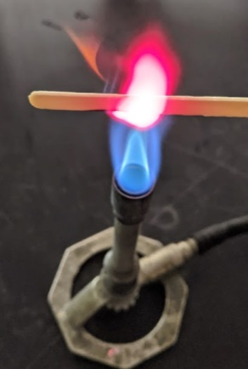
NaCl | 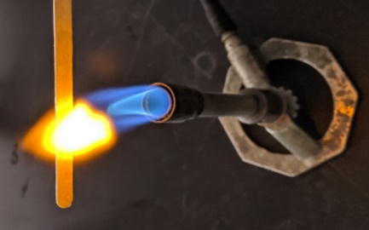
KCl | 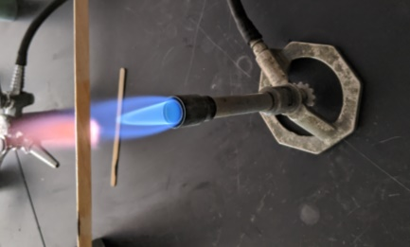

Group 2 Alkaline Earth Metals
CaCl₂ | 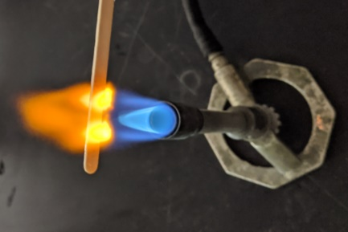
SrCl₂ | 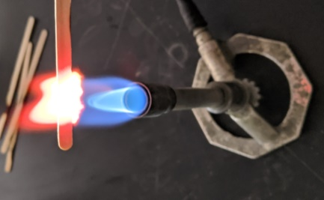
BaCl₂ | 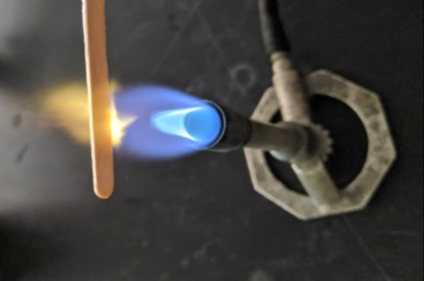  *Looks greener in real life

Group 17 Halides
NaCl
NaBr | 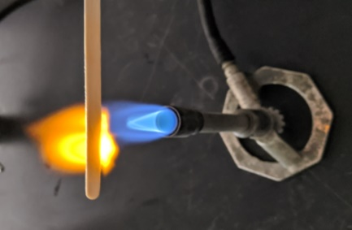
NaI | 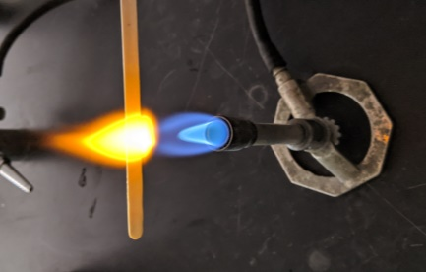

Transition Metals
CuCl₂ | 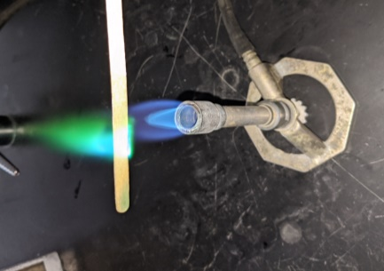
MnCl₂ | 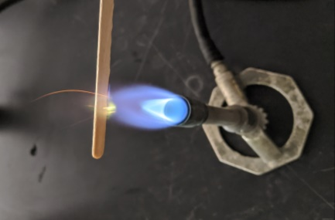  This one sparks

Unknowns (Choose 2)
Unknown 1 | 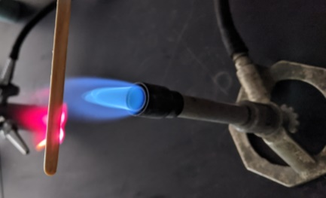
Unknown 2
Unknown 3 | 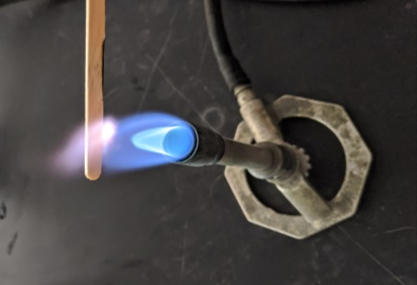
Unknown 4 | 